Semester Project

Date: June 1st, 2022

Supervisor: Group Members:

Sir Ahsan Shah 2020244 - Mohsin Zia

2020256 - Muhammad Abdullah

2020474 - Syed Irtaza Haider

2020526 - Zartaj Asim

**Revision History:**

|  |  |  |
| --- | --- | --- |
| ***Revision History*** | ***Date*** | ***Comments*** |
| 1.00 | 25/05/2022 | Major changes in databases. |

List of Contents

1 INTRODUCTION 4

1.1. PURPOSE 4

1.2. PRODUCT SCOPE 4

1.3 LIST OF TABLES…………………………………………………….

2 OVERVIEW 8

2.1 THE OVERALL DESCRIPTION 8

2.2 PRODUCT PERSPECTIVE 9

2.3 PRODUCT FUNCTIONS 9

2.4 USER CHARACTERISTICS 9

2.5 CONSTRAINTS 10

2.6 ASSUMPTIONS AND DEPENDENCIES 10

3 STATE OF THE ART 10

4 USER/SYSTEM REQUIREMENTS 12

4.1 External Interface Requirements 12

4.1.1 User Interfaces 12

4.1.2 Hardware Interfaces 12

4.1.3 Software Interfaces 12

4.1.4 Communication Interfaces 12

5 Functional Requirements 13

5.1 Functional Requirements with Traceability information 13

6 Nonfunctional Requirements & Software System Attributes 17

6.1 Performance Requirements 17

7 Project Design/Architecture 18

7.1 Architectural Design 18

Use Case View 18

Logical View 21

Development View 22

Following is the development view describing the architectural view to the end user. 22

Process View 23

Physical View 27

User Interface 28

ER Diagram 31

# INTRODUCTION

E-commerce has revolutionized the circulation of merchandise such that traditional businesses have adopted technology to maximize their efficiency. In this modern world of technology, our app is designed to meet the needs of wedding planning right at the fingertips.

It is a mobile-based application as well as a web-based application for event-related services. It allows the users to buy and provide services. It offers as a one-stop-shop space for the customer to explore vendors/venues, hotels, photographers, and car rentals. A company can register itself on the platform to provide a service, and the users can avail these services by registering themselves. Service provider and buyer have to create an account to use our website as well as application. It will provide the convenience of planning and shopping for your events without waiting in lines and ticking off the checklist. This web-app and mobile-based app helps our customers to find and connect with their dream team for their weddings and any event. They can explore their options by comparing services under their budgets. It will help the problem of comparing different options and exploring products and their prices under one web that will help the customer to shop easily. Customers can do bookings and we will receive their orders and their details and then can confirm orders through their contact information.

## PURPOSE

The purpose of this app is to allow customers to shop from the comfort of their couch for their weddings and events. It will provide them with services that will ease the wedding planning and any events related booking without having to travel because of the busy life schedule. It will also help customers with their budget planning such that they can look for the products at one stop and then make their purchase. The aim focus of this app is to facilitate people who want to plan their events without having to go through the chaos of window shopping and negotiating for the budgets. The app will help sellers promote their brands and will bring different enterprises to one platform helping the business and recognizing small brands’ work.

## PRODUCT SCOPE

The event-planning industry is a large industry and is worth billions of rupees. Karachi alone contributes 168 billion rupees. While wedding celebrations are an integral part of all cultures of Pakistan, organizing these events is a very hectic as well as time consuming process. Therefore our customers require a platform with the freedom to shop whenever they want without having to travel. The inconvenience for the customers who do not live close to the shopping areas have to travel for their event shopping will be eased by this app.

This project is worth compelling because it will allow customers to not wander through shops and plan their budgets. The app will take care of checking off the list for event-booking and will be bringing all the smaller enterprises that are part of different industries like hotels, photographers, car rentals, etc. to one platform and will make the process much smoother and easier.

The scope of this app is that it can be used by companies related to the event-planning industry all around Pakistan. It can later be grown to allow users to choose from hundreds of services with just a few clicks on their phones. It will help to promote and increase small brand recognition and will allow easy bookings.

Table 1: Terms used in this document and their description

|  |  |
| --- | --- |
| Name | Description |
| API | Application Programming Interface |
|  |  |
|  |  |

# LIST OF TABLES

**Web App**

**Mobile App**

# OVERVIEW

No similar app in the market has been available yet to ease the customer’s life of not having to wander from shop to shop looking for venues, caterers, and book halls for their events. Similar ideas have been executed in Pakistan but haven’t been mainstreamed yet. Our app is both android as well as iOS based. It is specifically designed for the users who would want to plan their events by paperless exchange between the customer and the buyer. Our app is a novel event look book designed for users to provide them to choose from hundreds of services available just a few clicks away on their phone.

## THE OVERALL DESCRIPTION

Our application can cater both the user who wants to avail the services and the seller who wants to provide the services. The app consists of only one type of user who can be the customer, or the buyer based on the services needed/provided. The user has to create an account and login in order to proceed. The inconvenience for the customers who do not live close to the shopping areas have to travel for wedding shopping will be eased by this app. The application will also be helpful to the sellers to get brand recognition.

The application facilitates the users in the following ways:

* If the user is a buyer, they can use the services available to them and choose from a variety of sellers. For instance, a hall at the desired location can be chosen first and then the user can opt for other options such as stage decoration, caterers, etc.
* Buyers can book services and we will receive their orders and the details. To confirm the order their contact information is asked during bookings.
* If the user is a seller, they can provide the information as well as images to give the customer a better idea of what services they will be getting. The app not only bring the services to a one-stop for an event but also help promote and increase small brand recognition.
* The application also provides a communication portal for users to message the service providers for queries. The 24/7 communication support will help with the queries and feedback.

The application is web as well as mobile based. Both the implementations are connected to different databases.

**Website**

The Website is created using HTML CSS and AJAX. PHP server is used to connect it to the database.

**Mobile App**

The mobile app will be developed using Flutter and Dart. NodeJS server is used to connect the data to the database server.

## PRODUCT PERSPECTIVE

Our app will open the doors of globalization for our customers to book for their events from their homes by going through their phones. It not only provides a service of convenience but also lets the user to compare prices and variety among different sellers. The app will be an emerging area for our sellers to get more market coverage. Moreover, with the recent uncertain situation of the Covid-19 the digital world has boomed and made people more reliable on online-shopping. This is when our app will help them with less physical contact and without going through the chaos of roaming around in markets for their events shopping/bookings. All of these services will be available to them just a few clicks away.

## PRODUCT FUNCTIONS

The main functions provided by our application are as follow:

* Book Services (Customer):
  + User will create an account and go through the services provided and compare among them to book what suits them the most.
* Provide Services (Sellers):
  + User will create an account and fill all the necessary information for their business to provide their services.
* View Available Services:
  + User can create an account and go through the services that are available without having to rush to book them.

## USER CHARACTERISTICS

To provide or buy services two types of users will be interacting with our application. The two users are as follow:

* Customers
  + Users interested in booking a hall, caterers, photographers, and rent-a-car, etc.
* Event Planning Companies
  + Sellers will be using the app to provide the services for our customers and to get market recognition

## CONSTRAINTS

Following are the constraints needed for the application:

* An active internet is required to go create an account and explore the services available. It is also a requirement to have a proper connection to provide or buy bookings.
* Valid login details are also required to create an account and use the services.
* User interface could be both Android as well as iOS

## ASSUMPTIONS AND DEPENDENCIES

Assumptions and dependencies of the application are listed as follow:

* User of the system can use the web-application as well as the mobile-based-app but must have access to an active internet connection.
* Both the web-based app and mobile-based app are dependent on an active internet while the customer is using it.
* User must have valid email and password to proceed to their account to avail the services.

# STATE OF THE ART

**LITERATURE REVIEW**

Booking halls, caterers and photographers have always been a hustle. Planning an event is almost like planning a chaos which is why our app is designed to meet the needs of event planning right at the fingertips.

It offers as a one-stop for customers to book for their events. It also lets the vendor to register and enter their product details for the customers.

In Pakistan, a few initiatives have been taken but haven’t been mainstreamed yet. Because the customer’s orders are not placed directly to the vendors through the web-app.

* **Shadi Welcome**
  + It is a web-based application that targets bookings for different events and weddings. It provides a list of services available. You select the type of the service and the city you want the services at. This app is very similar to our application, but the web-application has not been mainstreamed yet.
* **Venue Bazaar**
  + It is a web-based-application based in Karachi that takes care of services for customer’s wedding day. It asks the user to enter their location and the range for the bookings they have and then provides services for caterers, halls, and photographers.
* **Marriage Halls**
  + It is a certified web-based application that provides list of marriage halls for bookings and their information.
* **Booked.pk**
  + It is a Karachi based web-app for banquet halls but also provide list of services like event caterers, florists decorators, and car rentals.

**EXISTING SYSTEMS**

* **Shadi Welcome**
  + It is a web-based application that targets bookings for different events and weddings. It provides a list of services available. You select the type of the service and the city you want the services at. This app is very similar to our application, but the web-application has not been mainstreamed yet.
* **Venue Bazaar**
  + It is a web-based-application based in Karachi that takes care of services for customer’s wedding day. It asks the user to enter their location and the range for the bookings they have and then provides services for caterers, halls, and photographers.
* **Marriage Halls**
  + It is a certified web-based application that provides list of marriage halls for bookings and their information.
* **Booked.pk**
  + It is a Karachi based web-app for banquet halls but also provide list of services like event caterers, florists decorators, and car rentals.

# USER/SYSTEM REQUIREMENTS

## External Interface Requirements

### User Interfaces

Our app is user-friendly and easy to understand for our user. In case of an ambiguity a chatbot service is available 24/7.

The main page of our application is the login/signup page. If the user is new and haven’t registered before, they need to create a new account by entering valid information. Login details are also provided for an existing user.

After logging in the app provides the user with

* Book for an event
* Provide Service
* Chatbot
* Create a package for seller
* Search Category

The user can select any of the options. The customers can explore their options and when want to book a service they will be required to enter their details.

The seller can login and provide their services by uploading pictures and their information.

### Hardware Interfaces

The user should have the basic knowledge of using phone. An active internet connection is required to use the application. Moreover, the user should have valid login/signup information to use the application.

### Software Interfaces

For the development of the mobile based application Flutter, Dart and NodeJS is used. Whereas, for the web-based application HTML, CSS, AJAX, and PHP server to connect to the databased is used.

The main aim is to create a platform for two categories of people onto one platform so that they can provide services to sell, and customers can buy their services after exploring their options.

### Communication Interfaces

The key communication interfaces for our application are valid login/signup information to use the app. Basic communication will be done using an active internet connection.

# Functional Requirements

The functional requirements of our project are listed below.

## Functional Requirements with Traceability information

**FR-01:** In this requirement the user will be able to create an account to use the services of the event planner app.

|  |  |  |  |  |  |  |  |  |  |  |  |  |  |  |  |  |  |  |  |
| --- | --- | --- | --- | --- | --- | --- | --- | --- | --- | --- | --- | --- | --- | --- | --- | --- | --- | --- | --- |
| **Requirement ID** | FR-01 | | | | **Requirement Type** | | | | Functional | | | | | **Use Case #** | | | | | UC-01 |
| **Status** | ***New*** |  | ***Agreed-to*** | | | | - | ***Baselined*** | | | | - | ***Rejected*** | | | | | - |  |
| **Parent Requirement #** | None | | | | | | | | | | | | | | | | | | |
| **Description** | User can sign up and login into their account. | | | | | | | | | | | | | | | | | | |
| **Rationale** | Users will be able to use and navigate through the application after registering. | | | | | | | | | | | | | | | | | | |
| **Source** |  | | | | | | | | **Source Document** | | | | | | - | | | | |
| **Acceptance/Fit Criteria** | While entering the email, the user should follow proper email format to sign up and login. | | | | | | | | | | | | | | | | | | |
| **Dependencies** | None | | | | | | | | | | | | | | | | | | |
| **Priority** | ***Essential*** | | | Yes | | ***Conditional*** | | | | - | ***Optional*** | | | | | - |  | | |
| **Change History** | None | | | | | | | | | | | | | | | | | | |

**FR-02:** In this requirement the user will be able switch his/her account mode to seller or buyer.

|  |  |  |  |  |  |  |  |  |  |  |  |  |  |  |  |  |  |  |  |
| --- | --- | --- | --- | --- | --- | --- | --- | --- | --- | --- | --- | --- | --- | --- | --- | --- | --- | --- | --- |
| **Requirement ID** | FR-02 | | | | **Requirement Type** | | | | Functional | | | | | **Use Case #** | | | | | - |
| **Status** | ***New*** |  | ***Agreed-to*** | | | | - | ***Baselined*** | | | | - | ***Rejected*** | | | | | - |  |
| **Parent Requirement #** | FR-01 | | | | | | | | | | | | | | | | | | |
| **Description** | User can switch between account modes. | | | | | | | | | | | | | | | | | | |
| **Rationale** | While in buyer mode the user can buy services and when the user enters seller mode the user can make use of functions such as providing their services. | | | | | | | | | | | | | | | | | | |
| **Source** |  | | | | | | | | **Source Document** | | | | | | - | | | | |
| **Acceptance/Fit Criteria** | Users should have services that they want to sell to make use of seller mode. | | | | | | | | | | | | | | | | | | |
| **Dependencies** | None | | | | | | | | | | | | | | | | | | |
| **Priority** | ***Essential*** | | | Yes | | ***Conditional*** | | | | - | ***Optional*** | | | | | - |  | | |
| **Change History** | None | | | | | | | | | | | | | | | | | | |

**FR-03:** In this requirement the user will be able to search for categories they want to shop services for.

|  |  |  |  |  |  |  |  |  |  |  |  |  |  |  |  |  |  |  |  |
| --- | --- | --- | --- | --- | --- | --- | --- | --- | --- | --- | --- | --- | --- | --- | --- | --- | --- | --- | --- |
| **Requirement ID** | FR-03 | | | | **Requirement Type** | | | | Functional | | | | | **Use Case #** | | | | | - |
| **Status** | ***New*** |  | ***Agreed-to*** | | | | - | ***Baselined*** | | | | - | ***Rejected*** | | | | | - |  |
| **Parent Requirement #** | FR-01 | | | | | | | | | | | | | | | | | | |
| **Description** | Users can navigate to the search page, and search for the categories they want to see services for. | | | | | | | | | | | | | | | | | | |
| **Rationale** | Users can go directly to the category they want, instead of scrolling through the page. | | | | | | | | | | | | | | | | | | |
| **Source** |  | | | | | | | | **Source Document** | | | | | | - | | | | |
| **Acceptance/Fit Criteria** | User should enter the name of the category they want to see. | | | | | | | | | | | | | | | | | | |
| **Dependencies** | None | | | | | | | | | | | | | | | | | | |
| **Priority** | ***Essential*** | | | Yes | | ***Conditional*** | | | | - | ***Optional*** | | | | | - |  | | |
| **Change History** | None | | | | | | | | | | | | | | | | | | |

**FR-04:** In this requirement the user can create packages and add items into them.

|  |  |  |  |  |  |  |  |  |  |  |  |  |  |  |  |  |  |  |  |
| --- | --- | --- | --- | --- | --- | --- | --- | --- | --- | --- | --- | --- | --- | --- | --- | --- | --- | --- | --- |
| **Requirement ID** | FR-04 | | | | **Requirement Type** | | | | Functional | | | | | **Use Case #** | | | | | UC-02 |
| **Status** | ***New*** |  | ***Agreed-to*** | | | | - | ***Baselined*** | | | | - | ***Rejected*** | | | | | - |  |
| **Parent Requirement #** | FR-01 | | | | | | | | | | | | | | | | | | |
| **Description** | User will be able to create packages, and items into them. | | | | | | | | | | | | | | | | | | |
| **Rationale** | Packages are like carts; they allow user to add items into them and then checkout the whole package. This application allows the user to create as many packages as they want. So, the user can have multiple carts. | | | | | | | | | | | | | | | | | | |
| **Source** |  | | | | | | | | **Source Document** | | | | | | - | | | | |
| **Acceptance/Fit Criteria** | User should give a name to the package. User should first create a package to add services into it. | | | | | | | | | | | | | | | | | | |
| **Dependencies** | None | | | | | | | | | | | | | | | | | | |
| **Priority** | ***Essential*** | | | Yes | | ***Conditional*** | | | | - | ***Optional*** | | | | | - |  | | |
| **Change History** | None | | | | | | | | | | | | | | | | | | |

**FR-05:** In this requirement the user will be able to place an order by checking out the desired package or cancel an order.

|  |  |  |  |  |  |  |  |  |  |  |  |  |  |  |  |  |  |  |  |
| --- | --- | --- | --- | --- | --- | --- | --- | --- | --- | --- | --- | --- | --- | --- | --- | --- | --- | --- | --- |
| **Requirement ID** | FR-05 | | | | **Requirement Type** | | | | Functional | | | | | **Use Case #** | | | | | UC-02 |
| **Status** | ***New*** |  | ***Agreed-to*** | | | | - | ***Baselined*** | | | | - | ***Rejected*** | | | | | - |  |
| **Parent Requirement #** | FR-04 | | | | | | | | | | | | | | | | | | |
| **Description** | User can place an order by checking out the package after they have added their desired services in it. User can also cancel the order which they have placed before. | | | | | | | | | | | | | | | | | | |
| **Rationale** | As the user can have many packages and their desired items in them. This requirement allows user to checkout any of the package. | | | | | | | | | | | | | | | | | | |
| **Source** |  | | | | | | | | **Source Document** | | | | | | - | | | | |
| **Acceptance/Fit Criteria** | User should have created a package and have at least 1 item in that package to place an order. User should have placed an order to cancel it. | | | | | | | | | | | | | | | | | | |
| **Dependencies** | None | | | | | | | | | | | | | | | | | | |
| **Priority** | ***Essential*** | | | Yes | | ***Conditional*** | | | | - | ***Optional*** | | | | | - |  | | |
| **Change History** | None | | | | | | | | | | | | | | | | | | |

**FR-06:** In this requirement the user while being in seller mode will be able to create a service and delete a service.

|  |  |  |  |  |  |  |  |  |  |  |  |  |  |  |  |  |  |  |  |
| --- | --- | --- | --- | --- | --- | --- | --- | --- | --- | --- | --- | --- | --- | --- | --- | --- | --- | --- | --- |
| **Requirement ID** | FR-06 | | | | **Requirement Type** | | | | Functional | | | | | **Use Case #** | | | | | UC-01 |
| **Status** | ***New*** |  | ***Agreed-to*** | | | | - | ***Baselined*** | | | | - | ***Rejected*** | | | | | - |  |
| **Parent Requirement #** | FR-01 | | | | | | | | | | | | | | | | | | |
| **Description** | User will be able to create and provide his/her services. User can also remove the service that they are providing. | | | | | | | | | | | | | | | | | | |
| **Rationale** | User can create a service; the services can then be bought by other users on the application. | | | | | | | | | | | | | | | | | | |
| **Source** |  | | | | | | | | **Source Document** | | | | | | - | | | | |
| **Acceptance/Fit Criteria** | User should be switched to seller mode to create or remove services. | | | | | | | | | | | | | | | | | | |
| **Dependencies** | None | | | | | | | | | | | | | | | | | | |
| **Priority** | ***Essential*** | | | Yes | | ***Conditional*** | | | | - | ***Optional*** | | | | | - |  | | |
| **Change History** | None | | | | | | | | | | | | | | | | | | |

**FR-07:** In this requirement the user while being in seller mode can view and complete the sales that buyers have bought from him.

|  |  |  |  |  |  |  |  |  |  |  |  |  |  |  |  |  |  |  |  |
| --- | --- | --- | --- | --- | --- | --- | --- | --- | --- | --- | --- | --- | --- | --- | --- | --- | --- | --- | --- |
| **Requirement ID** | FR-07 | | | | **Requirement Type** | | | | Functional | | | | | **Use Case #** | | | | | - |
| **Status** | ***New*** |  | ***Agreed-to*** | | | | - | ***Baselined*** | | | | - | ***Rejected*** | | | | | - |  |
| **Parent Requirement #** | FR-01 | | | | | | | | | | | | | | | | | | |
| **Description** | User will be able to complete sales that the buyer has bought. | | | | | | | | | | | | | | | | | | |
| **Rationale** | When a buyer buys services from a seller, those services appear on the seller’s dashboard, the seller would than provide the service, and can complete it by pressing the service completed check. The buyer can then know that the service has been provided. | | | | | | | | | | | | | | | | | | |
| **Source** |  | | | | | | | | **Source Document** | | | | | | - | | | | |
| **Acceptance/Fit Criteria** | Someone should have bought a service from the user, for the user to complete it. | | | | | | | | | | | | | | | | | | |
| **Dependencies** | None | | | | | | | | | | | | | | | | | | |
| **Priority** | ***Essential*** | | | Yes | | ***Conditional*** | | | | - | ***Optional*** | | | | | - |  | | |

# Nonfunctional Requirements & Software System Attributes

* **Security**
  + Whenever a user wants to POST or GET data to and from the server, we have if you ensure that they are an authorized user. So, the REST API is implemented in such a way that to GET or POST data to it, the user must send an API key, through which the server recognizes if they are an authorized user or not.
* **Usability**
  + Our application is user friendly and a chatbot is available 24/7 for any ambiguity.
* **Reliability**
  + The application is reliable and perform the actions without any failure.
* **Accessibility**
  + Our app is user-friendly and is available for every layman to use and explore their options for their event bookings.

## Performance Requirements

Our performance requirements for the application are as follow:

* Speed of response
* Execution time
* Defining business rule
* Getting specifications of software development

1. **Project Design/Architecture**

## Architectural Design

## Use Case View

* **UC-01**

This is a brief use case diagram of our whole system. We have a user who can act as both a buyer as well as a service provider, and a database server.

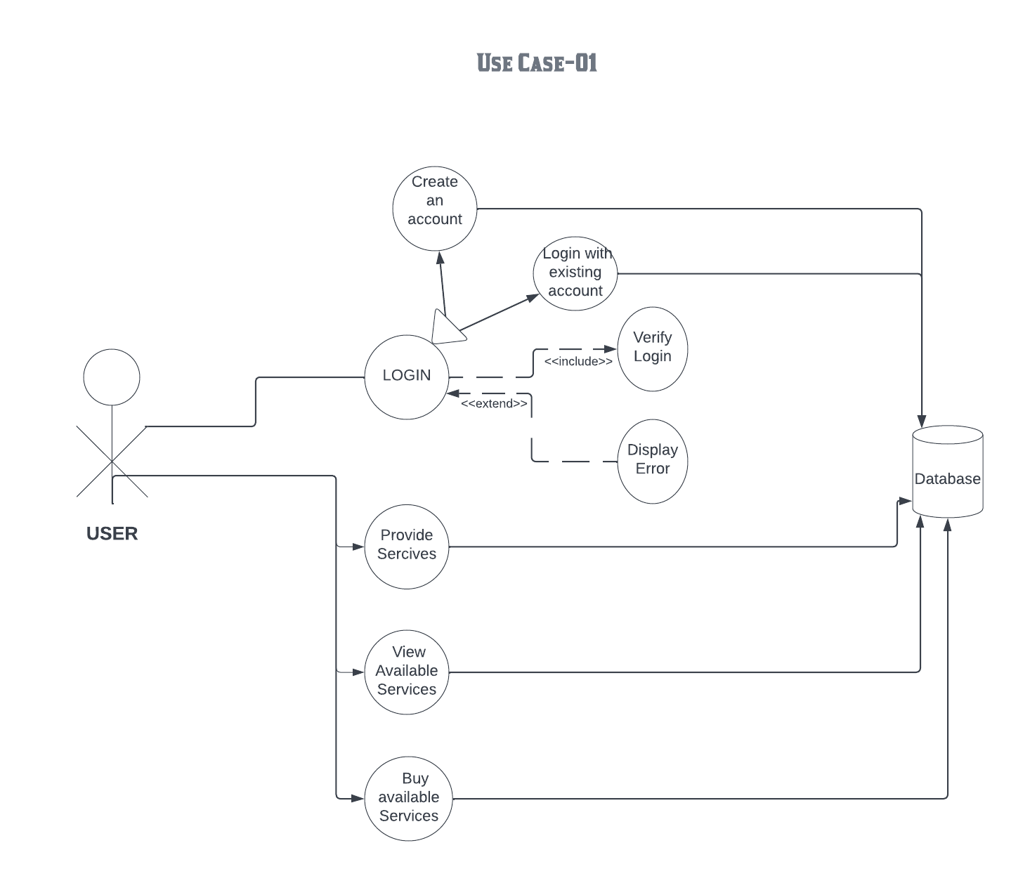

* **UC-02**

This is a use case diagram for service management.

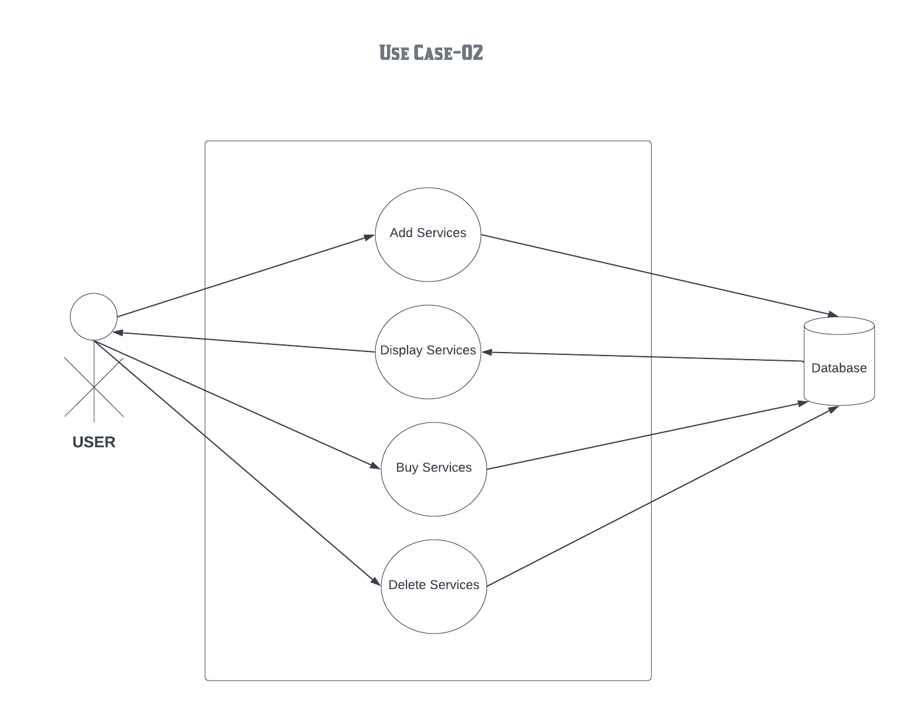

* **UC-03**

This is a use case diagram for managing cart and order system. User while being in buyer mode can place order for certain services, and the seller for that service can complete the order.

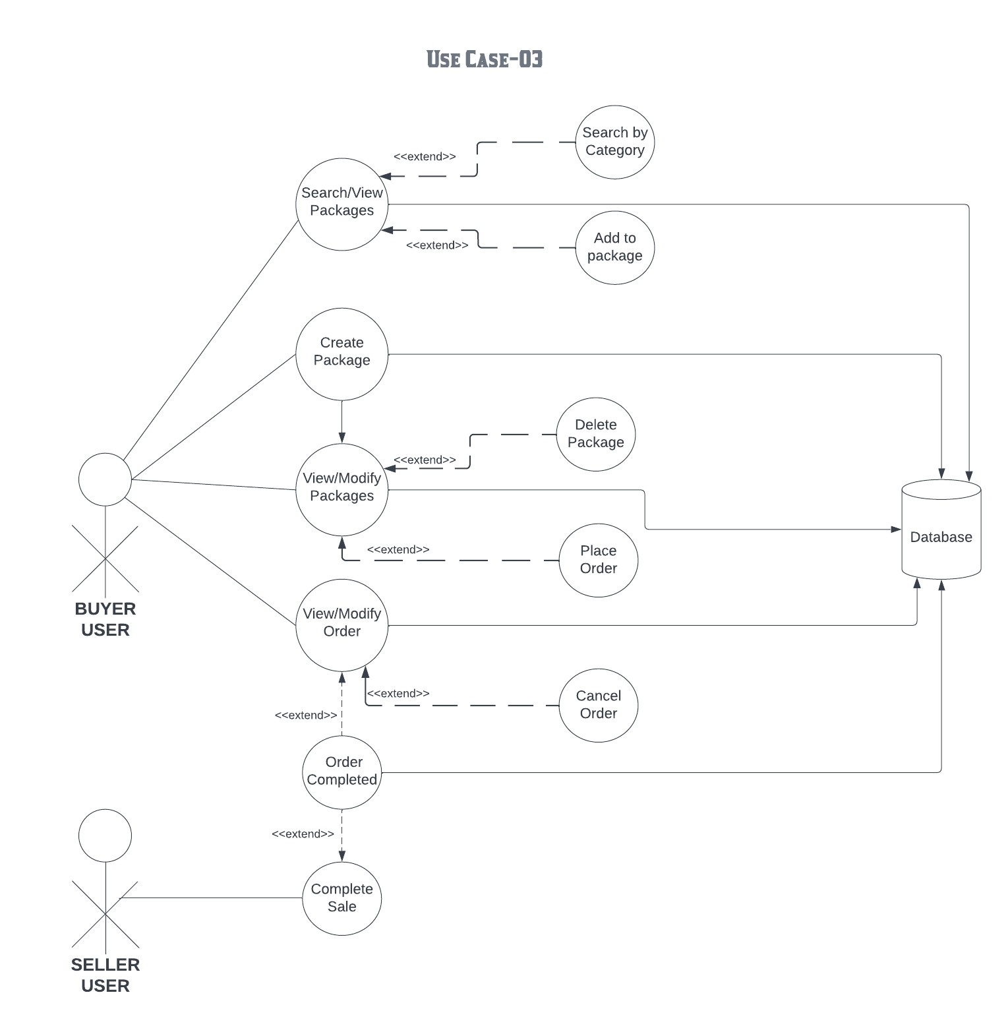

## Logical View

Logical view shows the functionality of the system to end user. Following is the class diagram of the logical view explaining the functionalities.

* **Class Diagram**

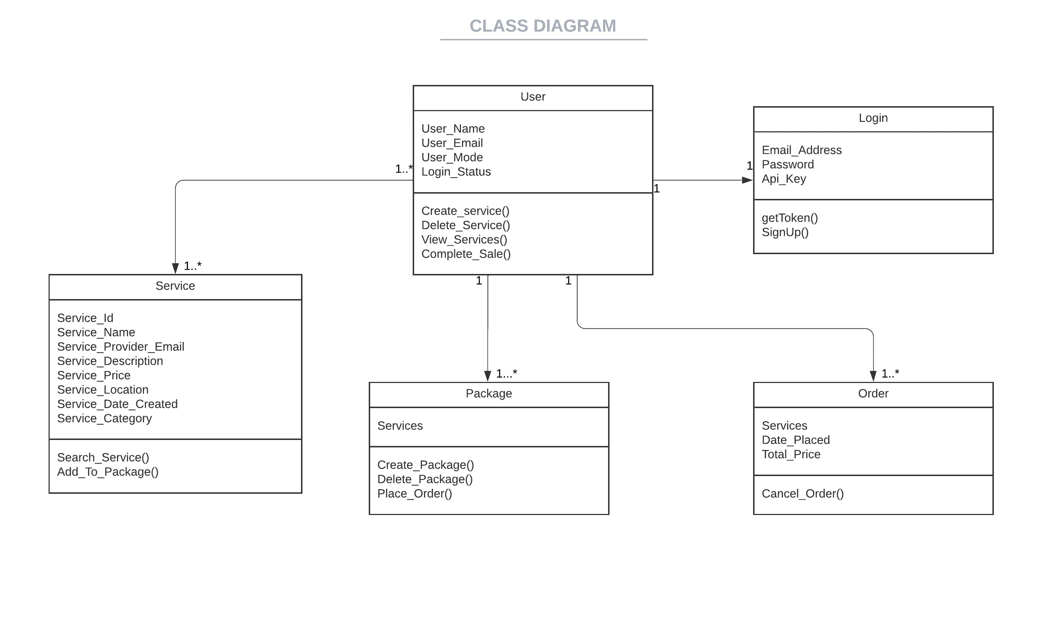

## Development View

## Following is the development view describing the architectural view to the end user.

## Process View

* **Activity Diagram**

Activity diagram shows the process view and shows the conditions and what happens after those conditions and then evaluate according to users condition.

* **Sequence Diagram**

Sequence diagram of app/web interaction of buyer with server and database.

Sequence diagram of app/web interaction of seller with server and database.

Sequence diagram of app/web interaction of user with server and login database.

## Physical View

Physical view of how user interacts with web/app server, and he can send requests to server or take requests from server (if any) and then server upload to data base or fetches from data base as per user request.

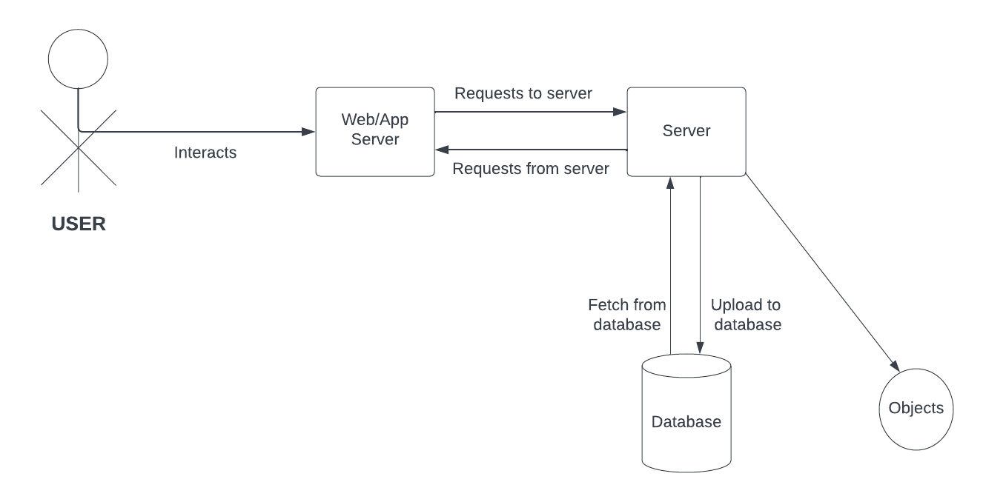

## User Interface

Following are the user interfaces of our mobile application.

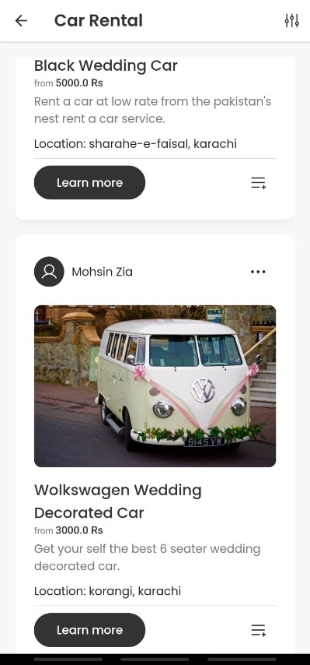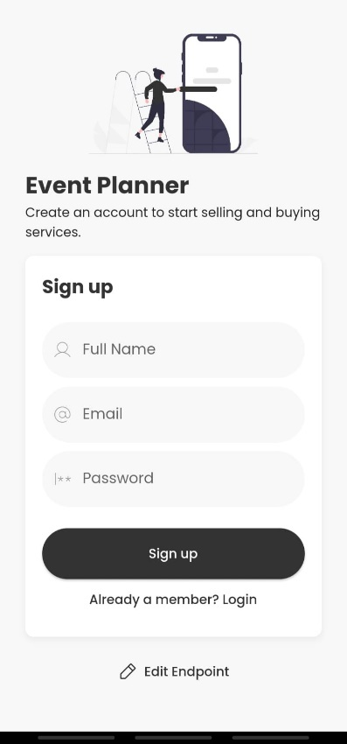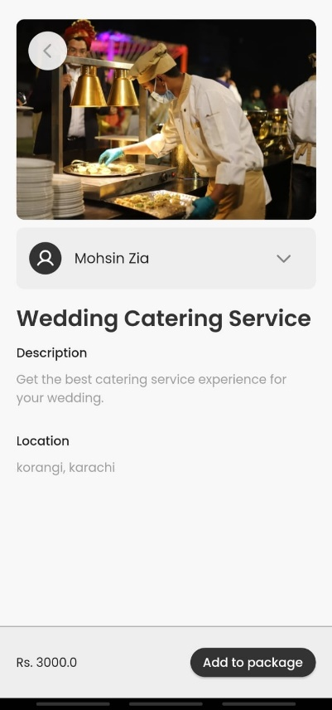

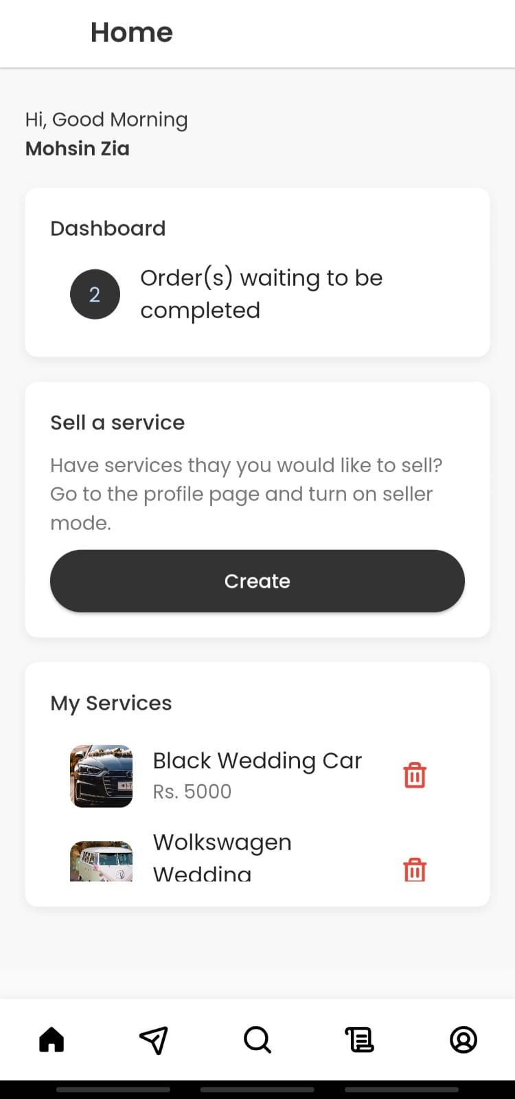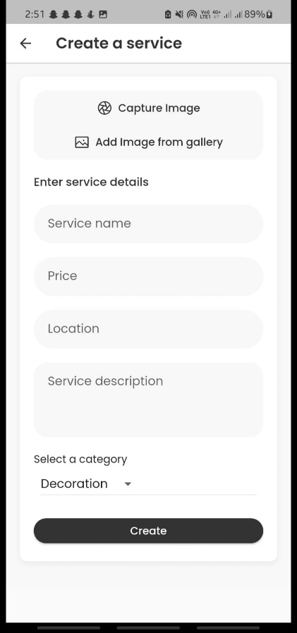

s

Following are the user interfaces of our web-based application.

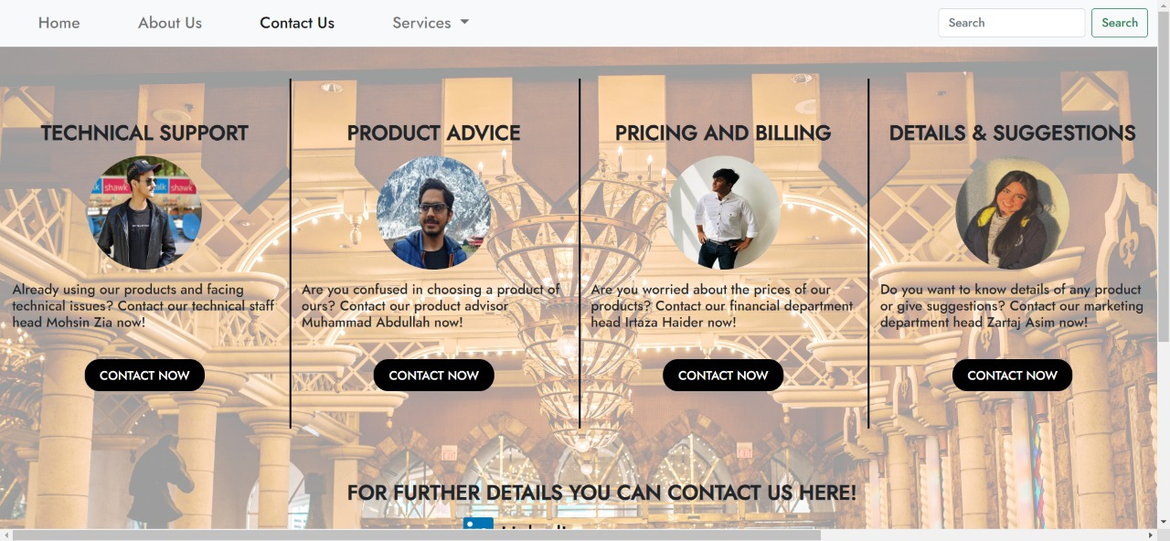

## ER Diagram

In the ER diagram below we have four major entities namely User, Package, Orders and Services which have their relations with each other. The details of attributes and relations of these entities are listed below:

Entities: User, Package, Orders and Services.

Attributes:

User: userID, userEmail, username, userPw.

Package: userID(FK), packageID, serviceName, count.

Order: userID(FK), orderID, serviceName, count, status, dateCreated.

Services: sellerID(FK), productID, Category, address, image, price.

